MongoDB

1. Open VS Code and connect to MongoDB.

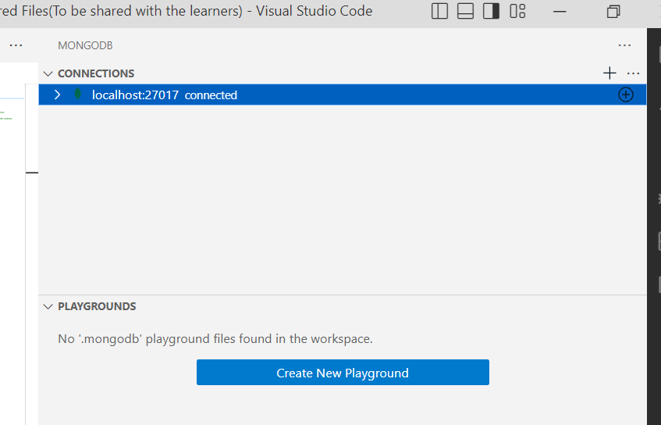

2. Create a database "ProductOrder" and create collections

"Product”, “Inventory", "User", and "Order" in it.

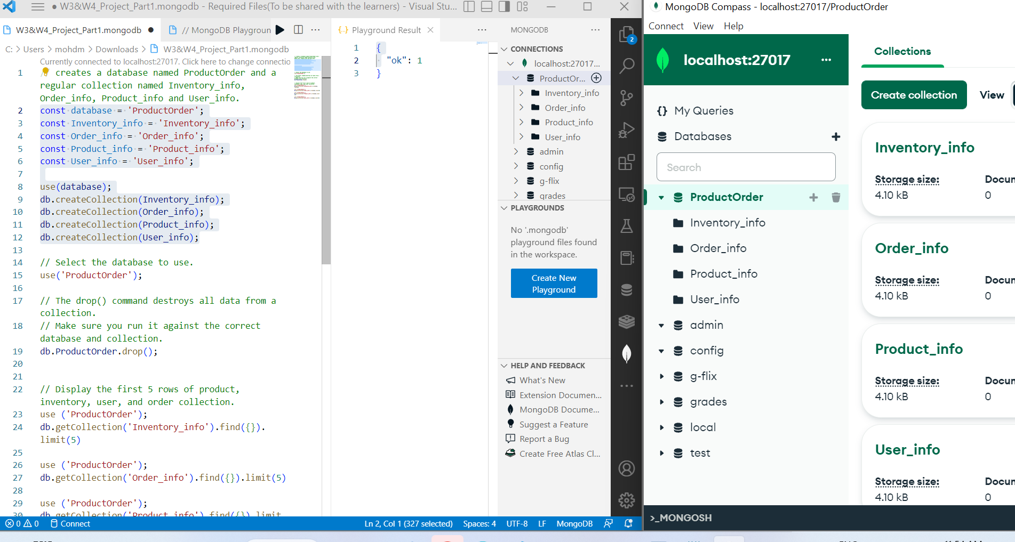

3.Open MongoDBCompass and navigate to the "ProductOrder" database.

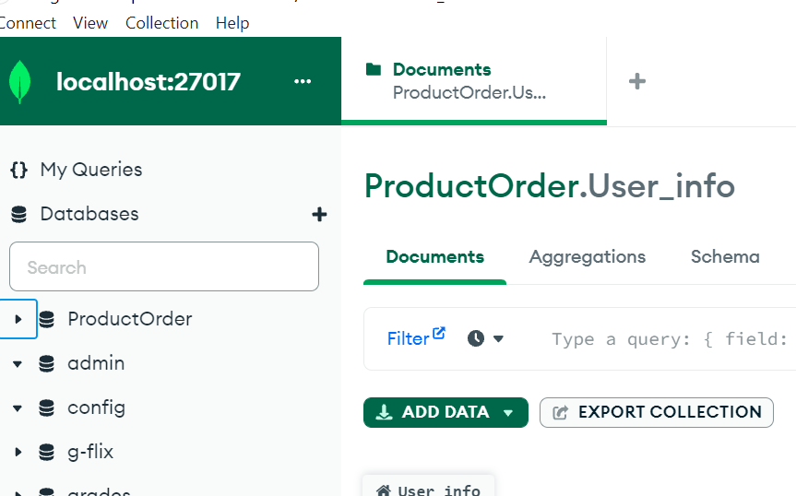

1. Add "Product_info. json" file into the "Product" collection.

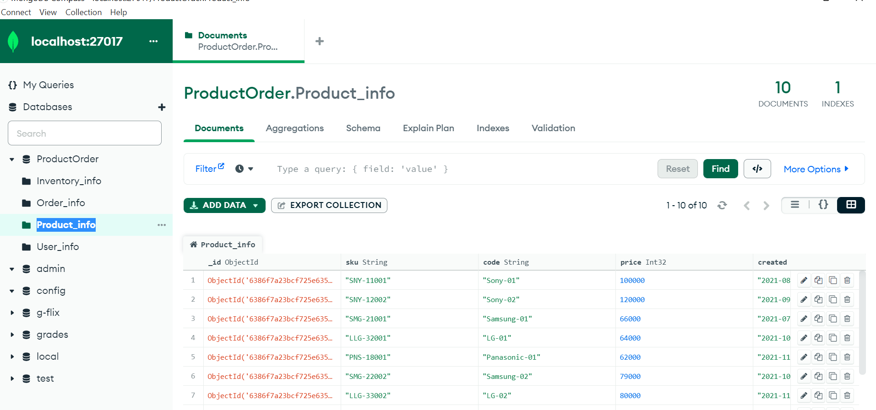

1. Add "Inventory_info.json" file into "Inventory" collection.

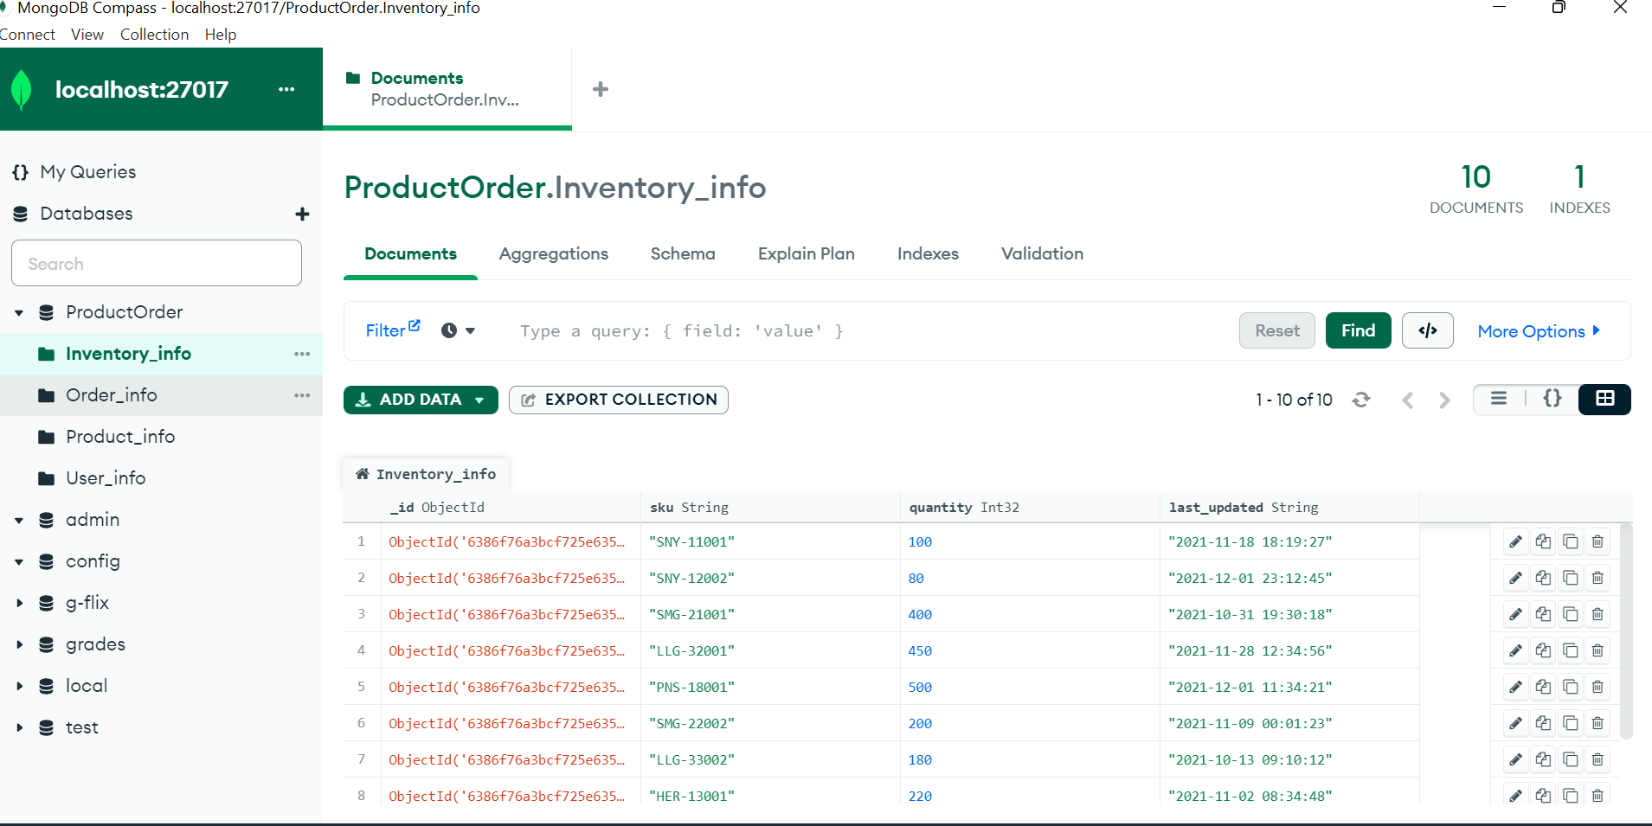

1. Add "User_info.json" file into the "User" collection.

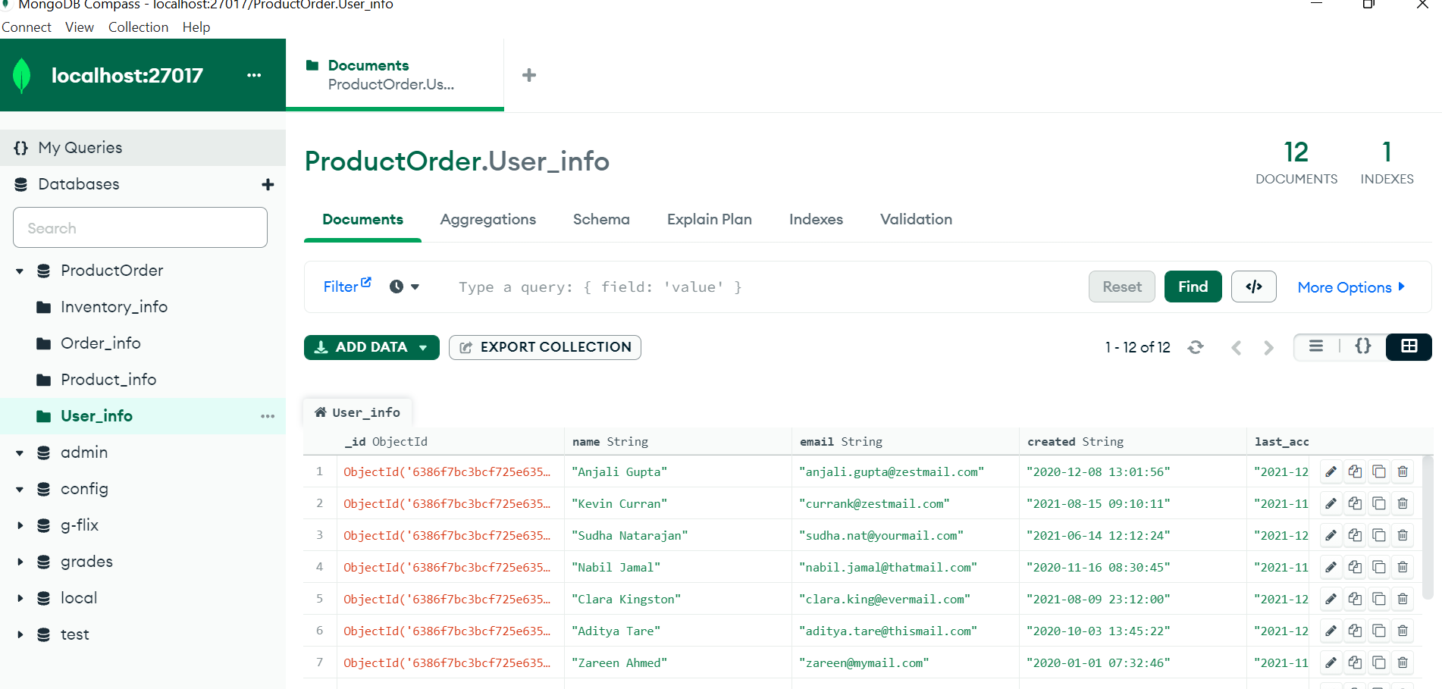

1. Add "Order_info.json" file into "Order" col

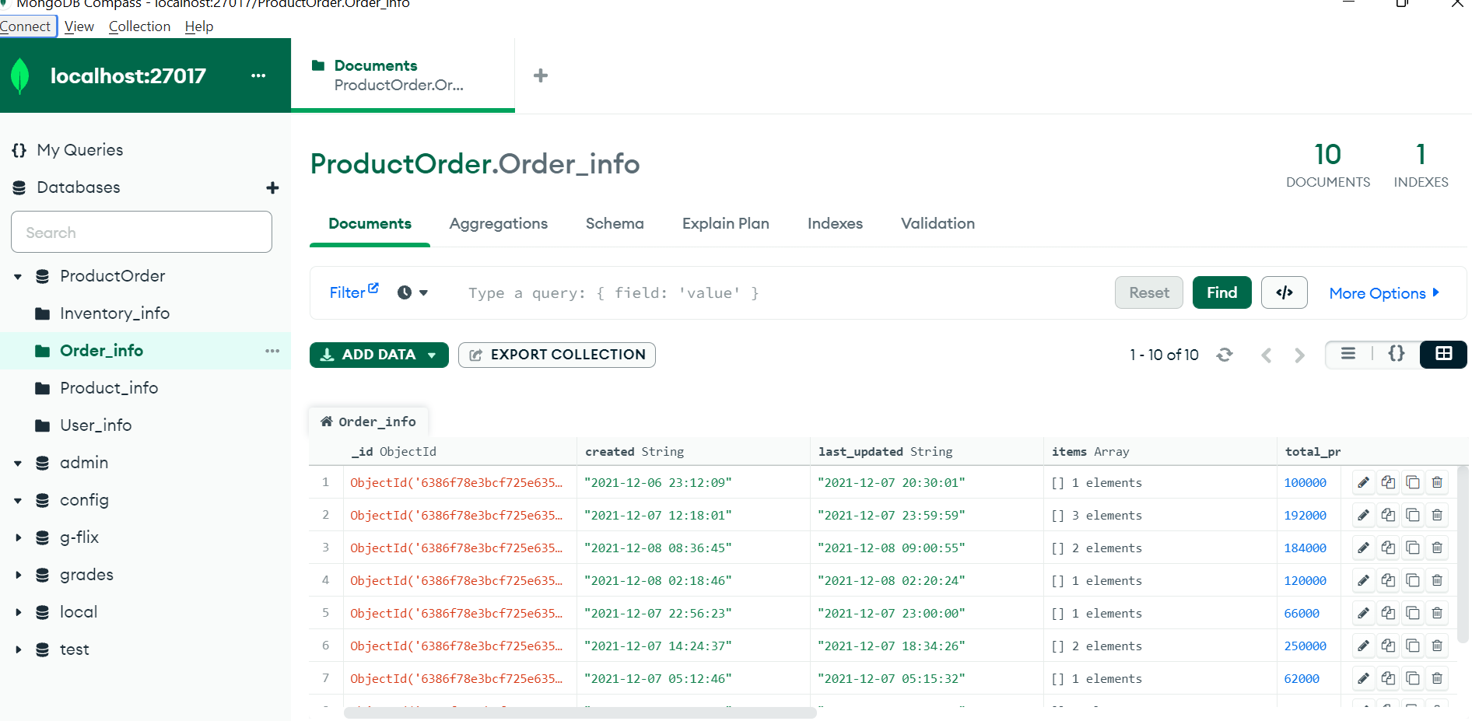

4.Display the first 5 rows of product, inventory, user, and order collection.

First 5 Rows of Product:

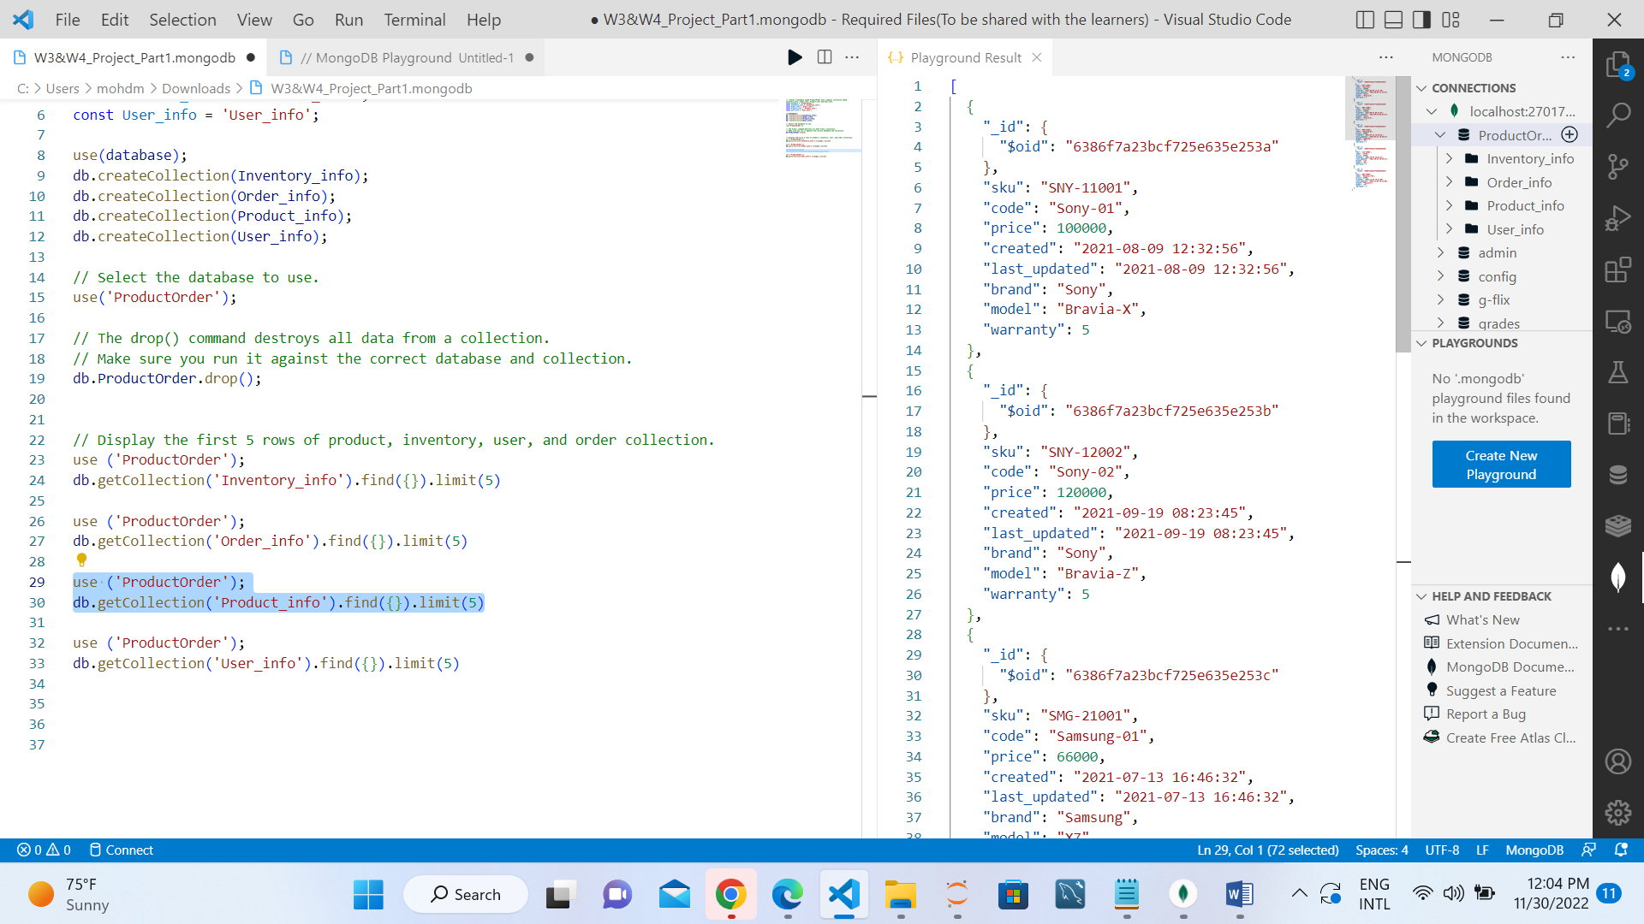

First 5 Rows of Inventory:

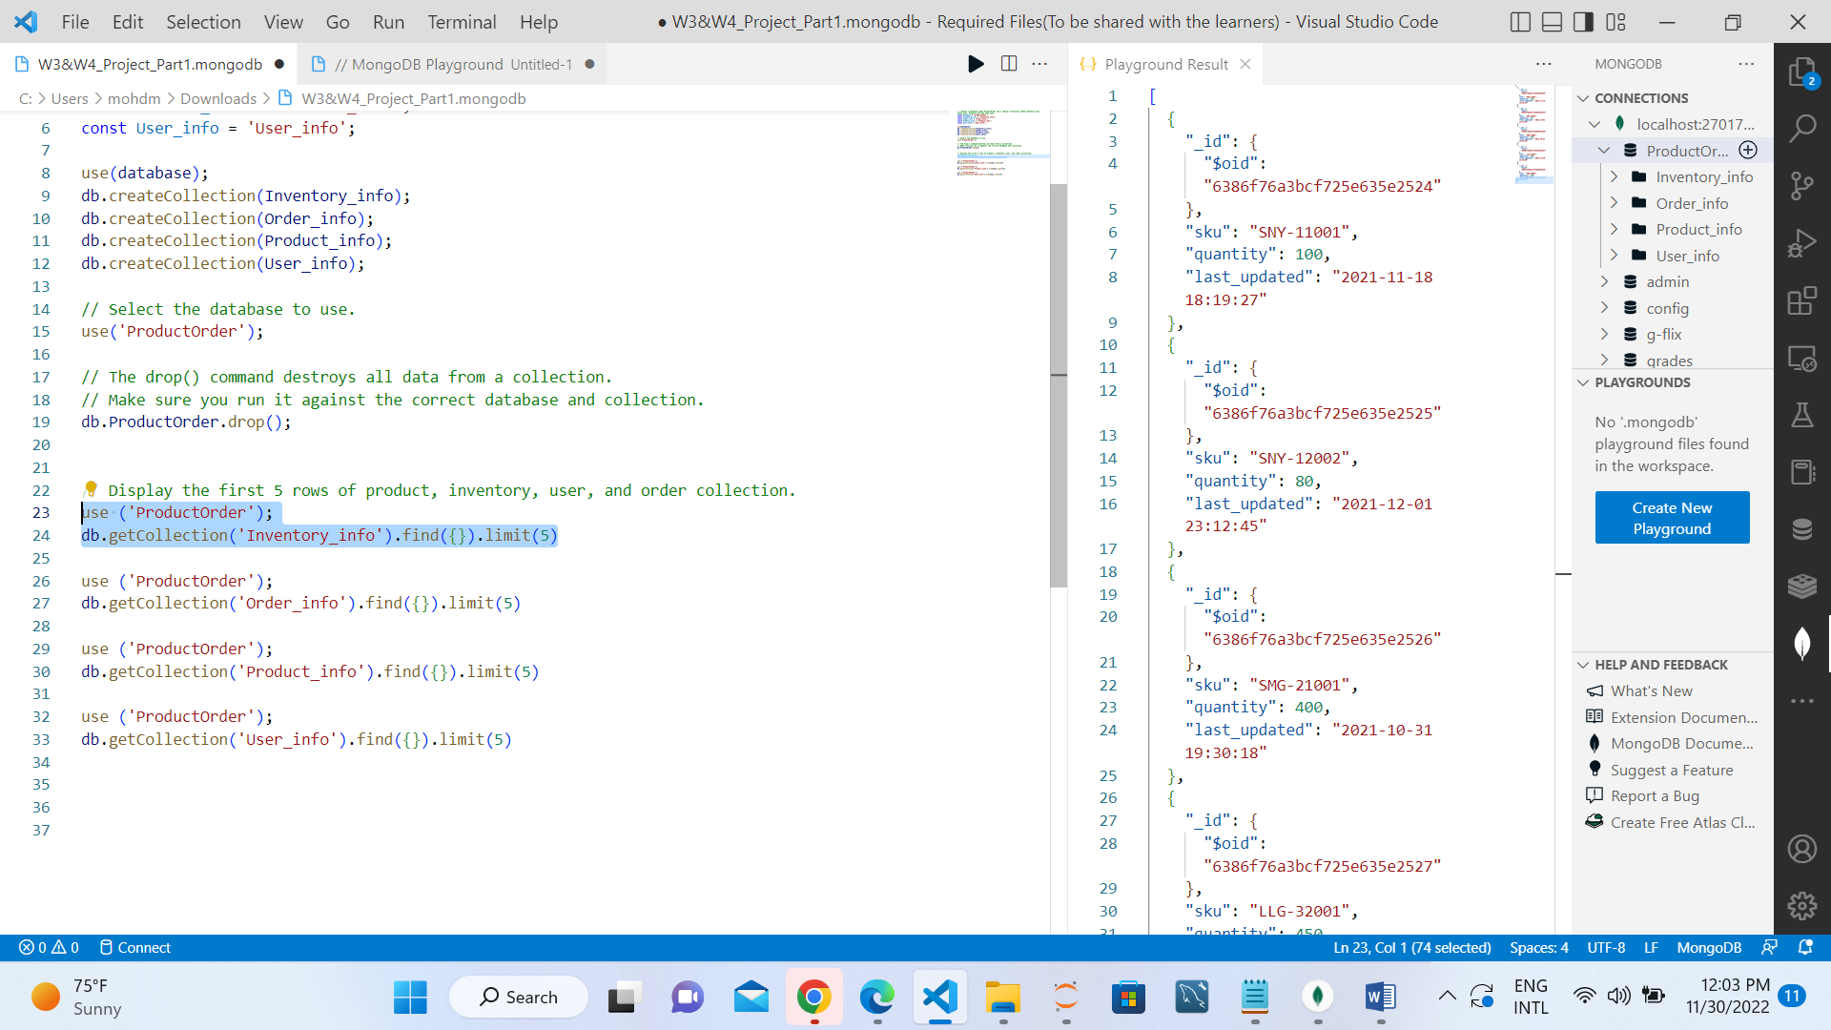

First 5 rows of Order:

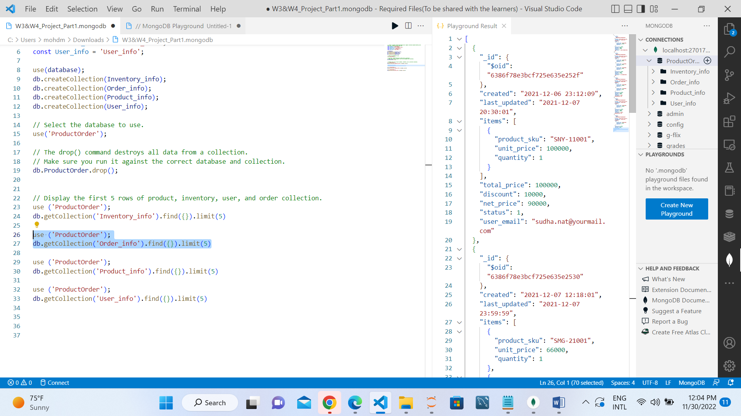

First 5 rows of User:

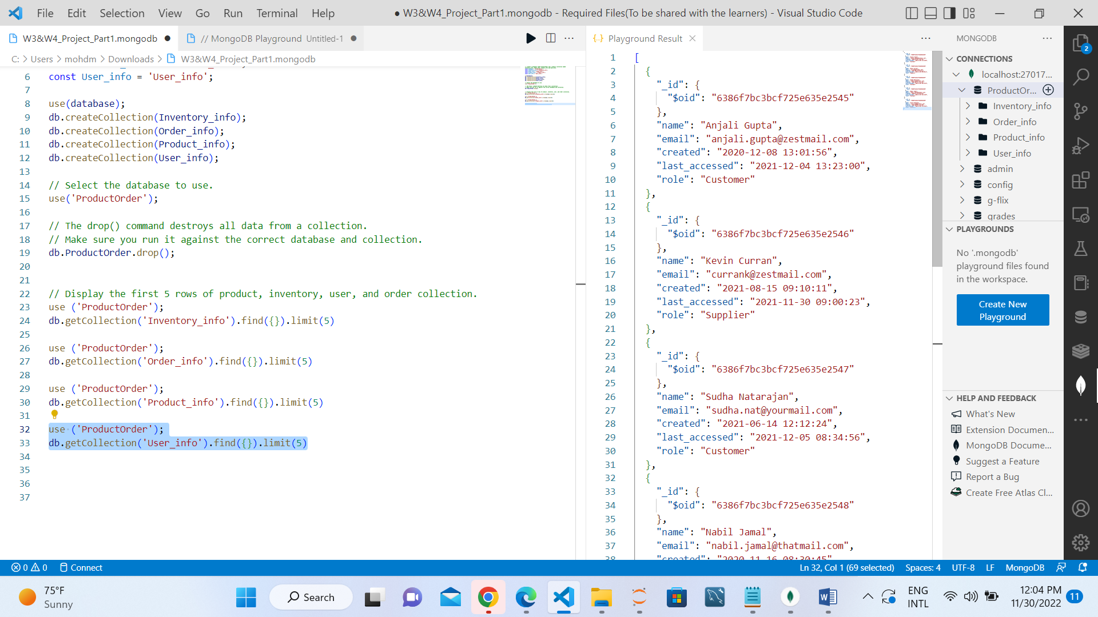

5.Display the Unique Brand and Model names from the Product collection.

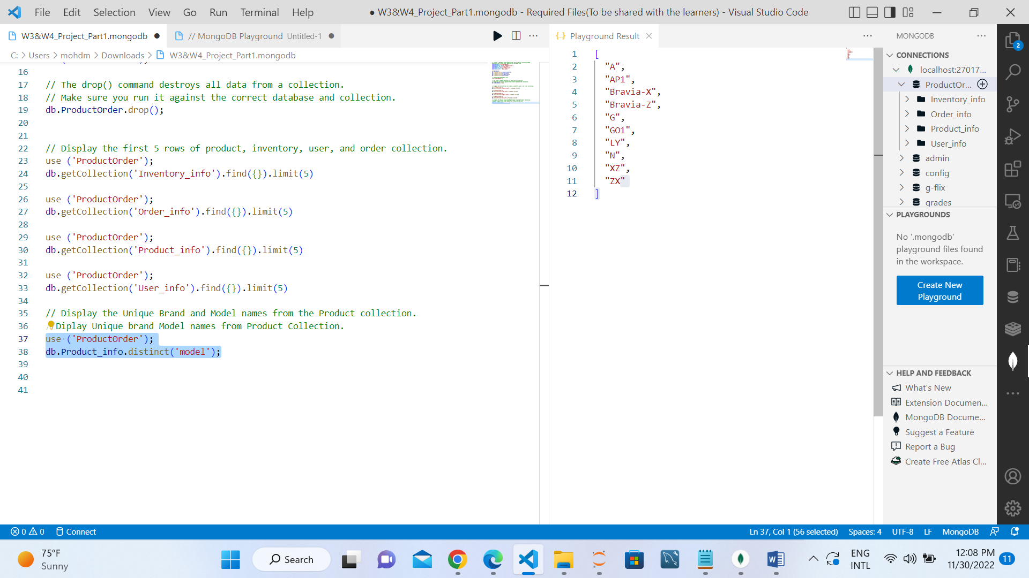

6.Find the maximum and minimum price of the given products.

Maximum Price:

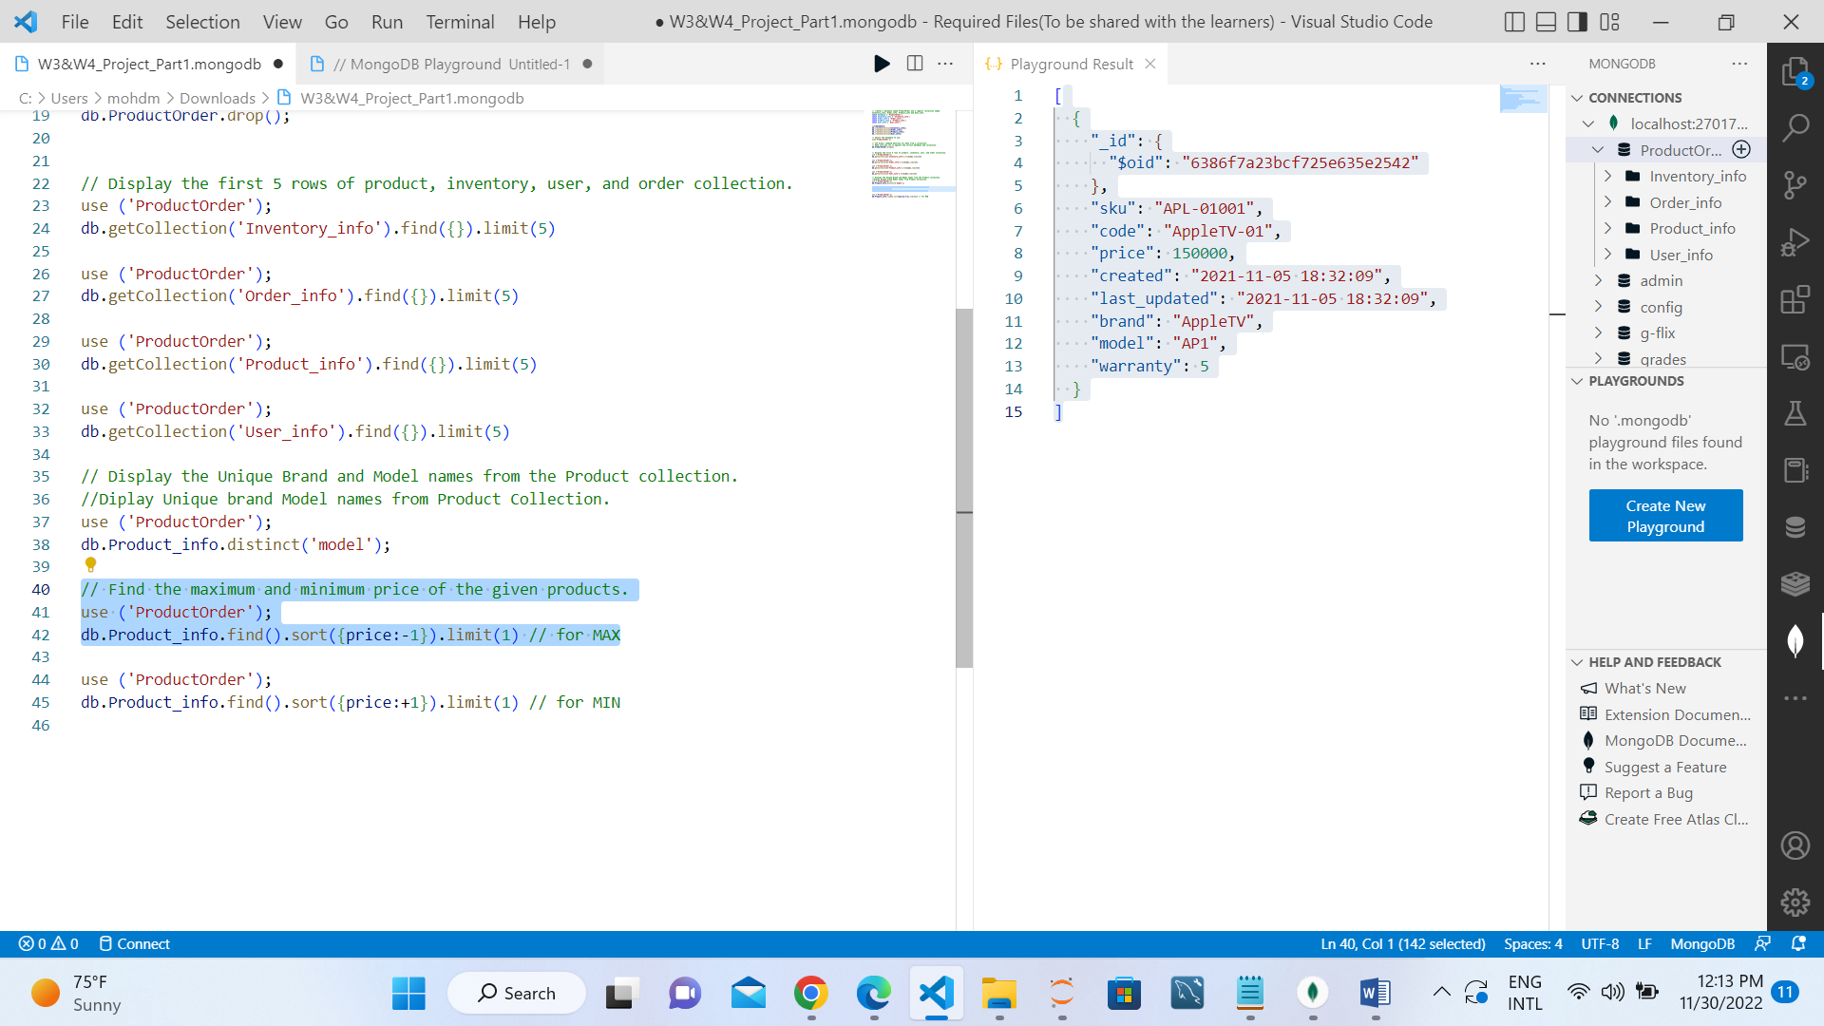

Minimum Price:

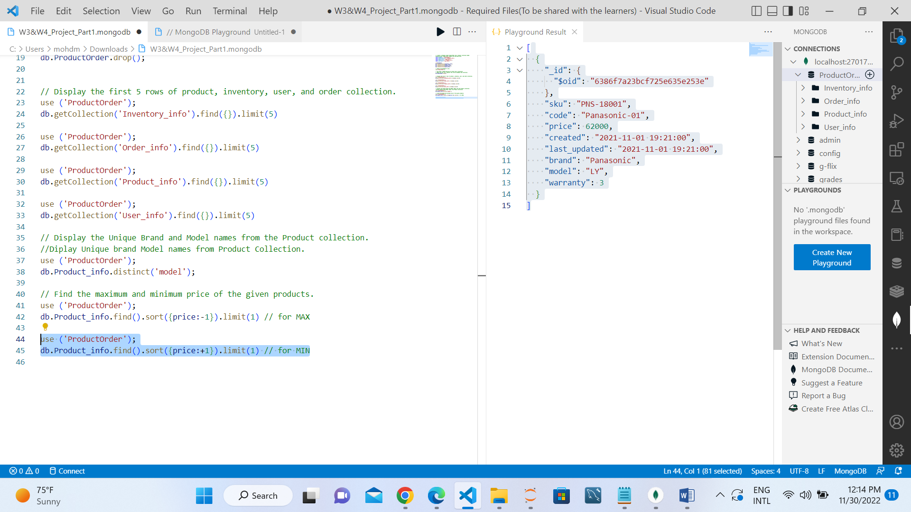

7. Display the quantity and last_updated date and time for sku "SNY-11001".

Quantity of sku "SNY-11001":

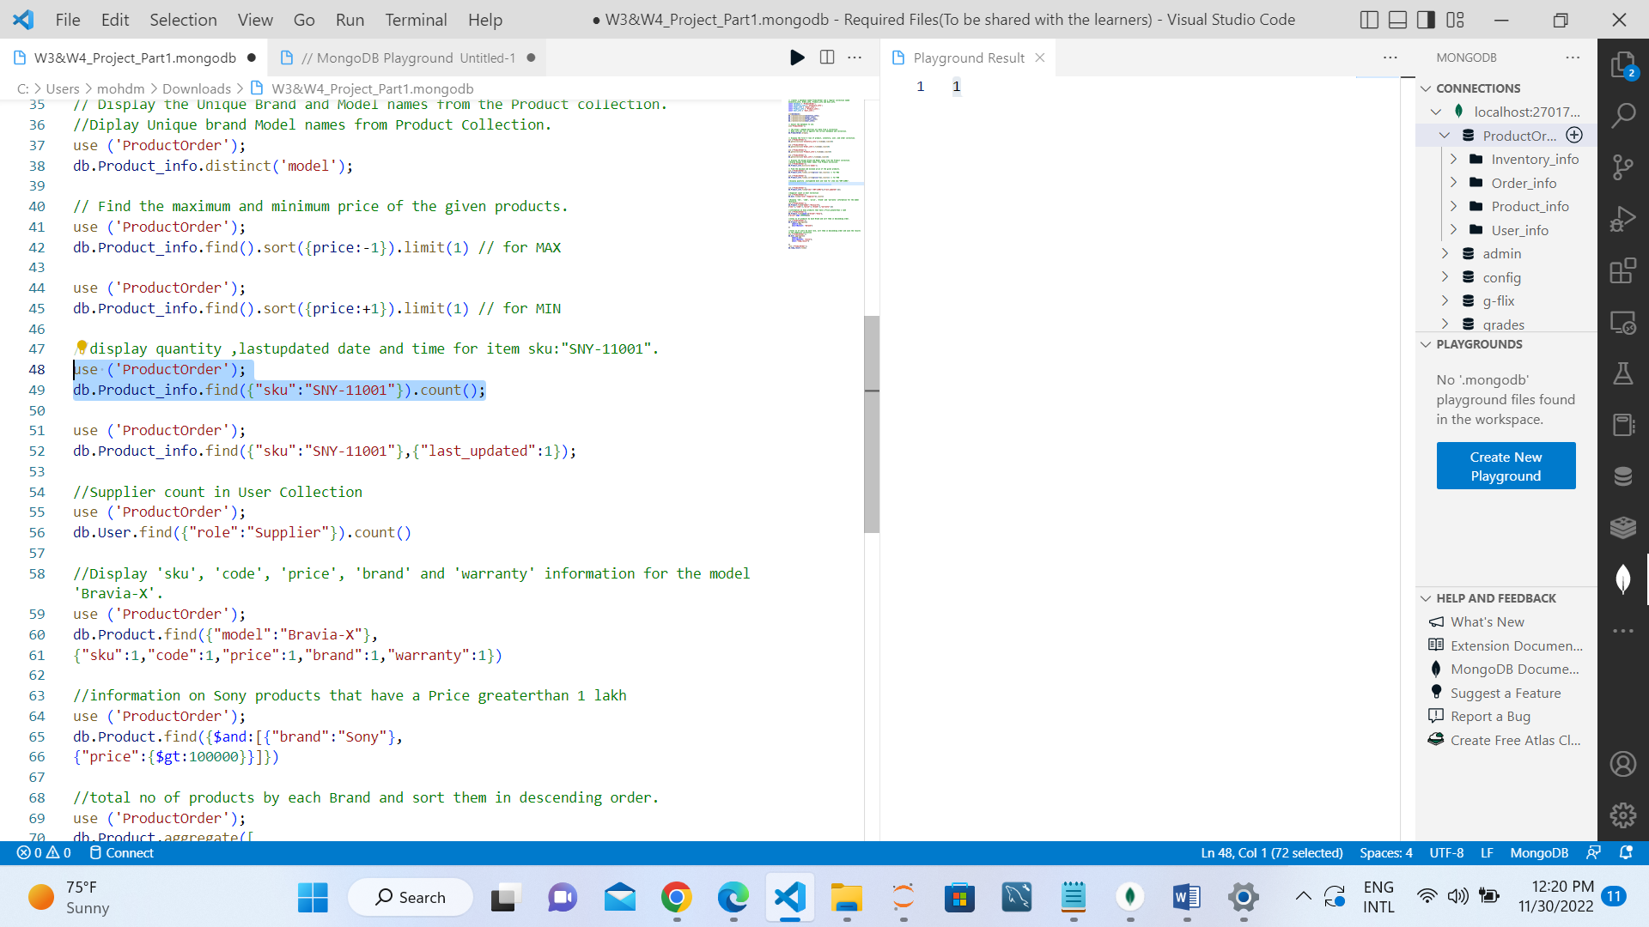

LastUpdate and time:

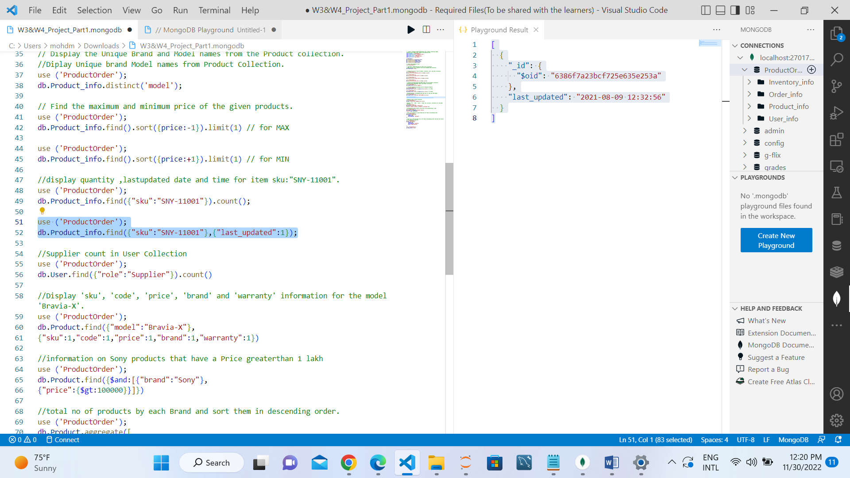

8. List down the count of the total number of users whose role is identified as 'Supplier' from User collection

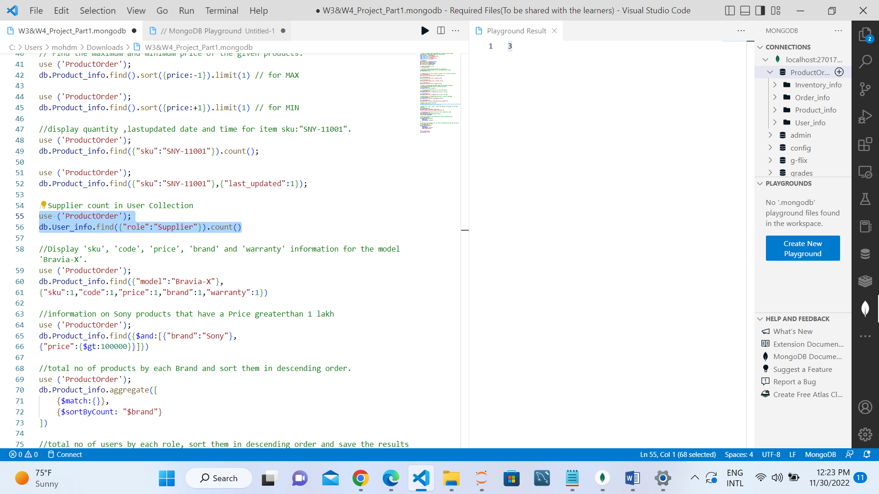

9. Display 'SKU', 'code', 'price', 'brand' and 'warranty' information for the model 'Bravia-X'.

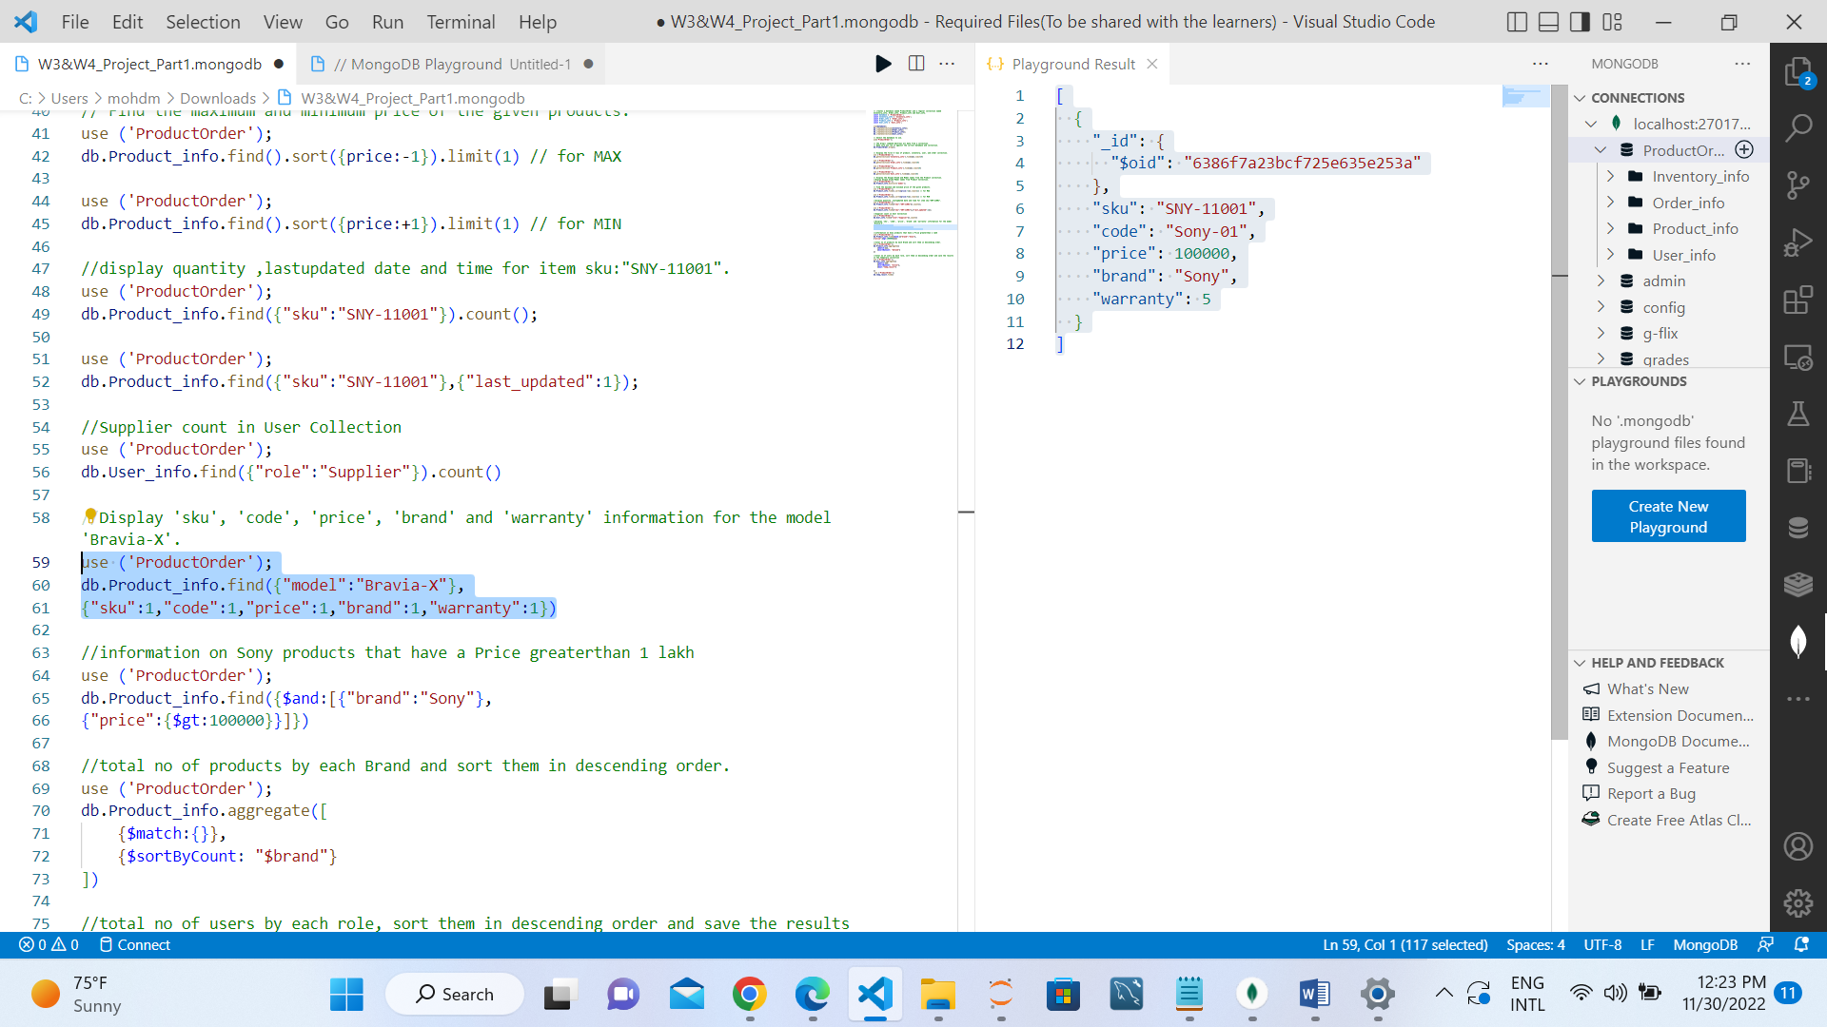

10. Find all the information on Sony products that have a Price greater than 1 lakh.

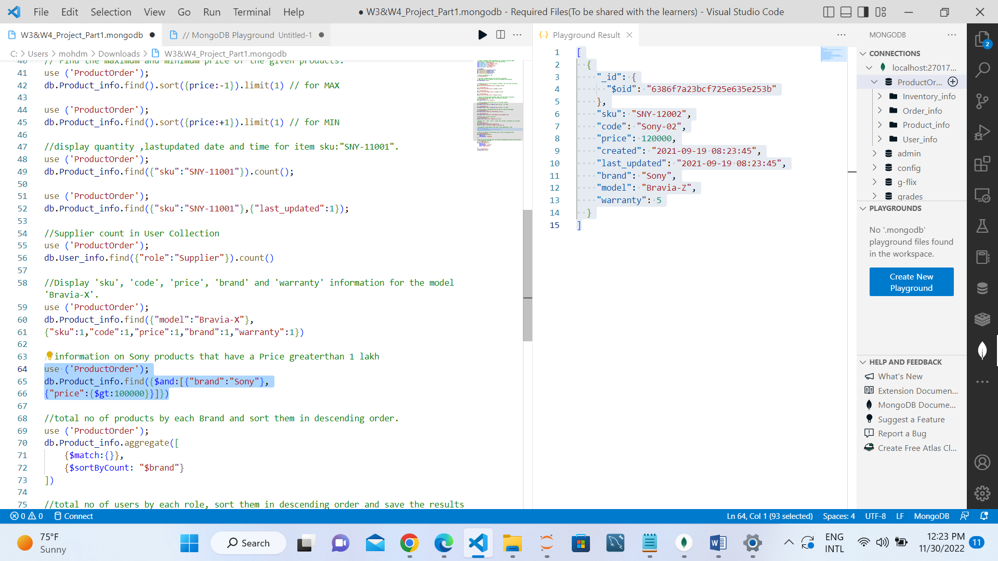

11. Find the total no of products by each Brand and sort them in descending order.

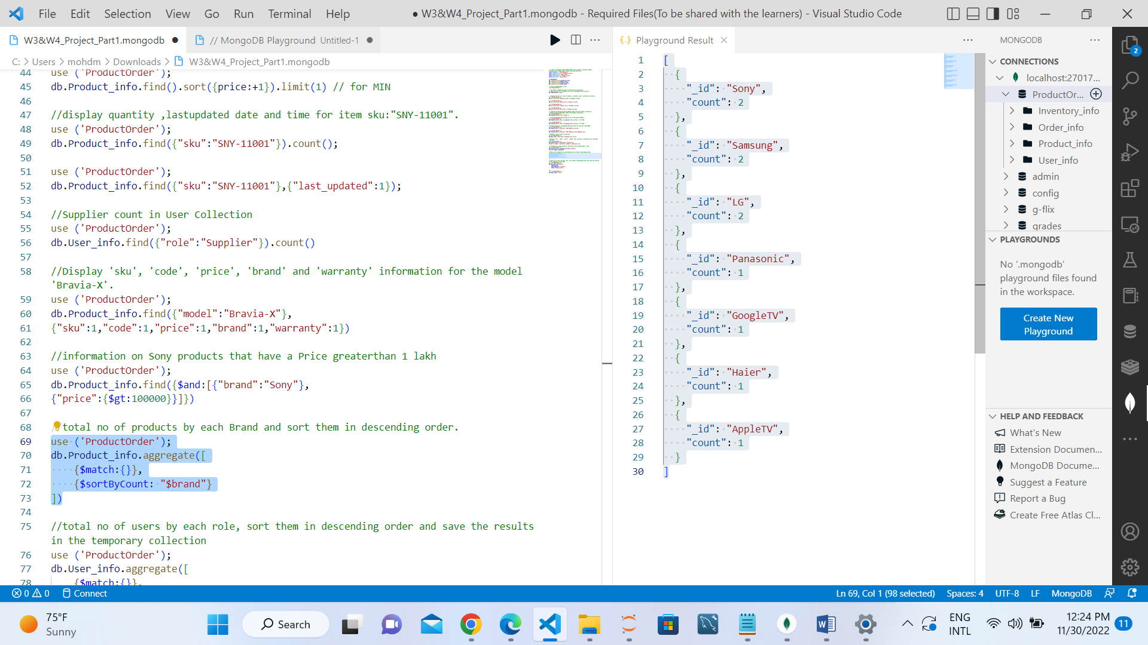

12. Find the total no of users by each role, sort them in descending order and save the results in the temporary collection .

